ICD-10 Follow On Class 1 Software Remediation Project

Clinical Case Registries (CCR)
Application Version 1.5

Release Notes
ROR*1.5*19



August 2014

Department of Veterans Affairs
Office of Information and Technology
Product Development

Table of Contents

1. Introduction 1
1.1. Purpose 1
1.2. Background 1
1.3. Scope of Changes 2
1.4. Dependent Patches 2
1.5. Dependent Constraints 3
1.6. Documentation 3
2. Reason for Selection 4
2.1. Dual Code Display 4
3. Diagnoses and Procedures Reports 6
3.1. Diagnosis Reports 6
3.2. Procedure Reports 7
4. ICD Diagnosis or Procedure Code Search 8
5. ICD Diagnosis Code Extract 9
5.1. Historical Encounters 9
6. ICD Diagnosis and Procedure Code Transmission 10
7. Technical Information 11
7.1. Routines 11
8. GUI Installation Instructions 12
8.1. Pre-Installation Instructions 12
8.2. UnInstall Instructions 13

(This page intentionally left blank)

Introduction

Purpose
The purpose of these Release Notes is to identify enhancements to the Clinical Case Registries (CCR) package contained in patch ROR*1.5*19.

Background
On January 16, 2009, the Centers for Medicare & Medicaid Services (CMS) released a final rule for replacing the 30-year-old International Classification of Diseases, Ninth Revision, Clinical Modification (ICD-9-CM) code set with International Classification of Diseases, Tenth Revision, Clinical Modification (ICD-10-CM) and International Classification of Diseases, Tenth Revision, Procedure Coding System (ICD-10-PCS) with dates of service or dates of discharge for inpatients that occur on or after the ICD-10 activation date.
The classification system consists of more than 68,000 codes, compared to approximately 13,000 ICD-9-CM codes. There are nearly 87,000 ICD-10-PCS codes, while ICD-9-CM has nearly 3,800 procedure codes. Both systems also expand the number of characters allotted from five and four respectively to seven alpha-numeric characters. This value does not include the decimal point, which follows the third character for the ICD-10-CM code set. There is no decimal point in the ICD-10-PCS code set. These code sets have the potential to reveal more about quality of care, so that data can be used in a more meaningful way to better understand complications, better design clinically robust algorithms, and better track the outcomes of care. ICD-10-CM also incorporates greater specificity and clinical detail to provide information for clinical decision making and outcomes research.
ICD-9-CM and ICD-10-CM Comparison
ICD-9-CM | ICD-10-CM
13,000 codes (approximately) | 68,000 codes (approximately)
3-5 characters | 3-7 characters (not including the decimal)
Character 1 is numeric or alpha (E or V) | Character 1 is alpha; character 2 is numeric;
Characters 2 - 5 are numeric | Characters 3–7 are alpha or numeric (alpha characters are not case sensitive)
Decimal after first 3 characters | Same
ICD-9-CM and ICD-10-PCS Comparison
ICD-9-CM Procedure Codes | ICD-10-PCS
3-4 characters | 7 alphanumeric characters
All characters are numeric | Characters can be either alpha or numeric. Letters O and I are not used to avoid confusion with the numbers 0 and 1.
All characters are numeric | Each character can be any of 34 possible values. The ten digits 0-9 and the 24 letters A-H, J-N and P-Z may be used in each character.
Decimal after first 2 characters | Does not contain decimals

Scope of Changes
NOTE: Existing ICD-9 functionality has not changed.
Patch ROR*1.5*19 makes the following changes to the CCR application:
- ICD-10-CM replaces ICD-9-CM as the diagnostic coding system for outpatient encounters with an encounter date on or after the ICD-10 Activation Date and inpatient treatment episodes with a discharge date on or after the ICD-10 Activation Date.
- ICD-10-PCS replaces the ICD-9-CM procedural coding system for inpatient treatment episodes with a discharge date on or after the ICD-10 Activation Date.
- There will be a period of time when VHA requires the use of dual code sets (ICD-9-CM, ICD-10-CM/ICD-10-PCS) to accommodate outpatient dates of service and inpatient discharge dates prior to and following the compliance date (the ICD-10 Activation Date) as well as for reporting and research purposes.
- Registry update process has been changed so that Reason for Selection for a patient added to a Registry can also be ICD-10 code in outpatient file, ICD-10 code in inpatient file or ICD-10 code in problem list.
- You can search for both ICD-10 diagnosis and procedure codes in the Report parameters, and Reports will show both sets of codes.
- ICD-10 diagnoses codes can be saved in Your Templates along with ICD-9 diagnoses codes.
- Common Templates have been updated to include ICD-10 codes.
Note: Pre-install routine saves the current Common Templates in ^TMP("ROR",$J) global before updating them with ICD-9 and ICD-10 codes. Any changes done to Common Templates will be lost after the installation of this patch.
- CCR Registry information that is sent to the National Database via HL7 messages now can differentiate between ICD-9 and ICD-10 diagnosis codes.
Note 1: The CCR PD team released CCR Patch ROR*1.5*17 on June 18, 2012, which added the new PTSD Common Template and two new HEPC reports.
Note 2: The CCR PD team also released CCR Patch ROR*1.5*18, which includes the minimal technical code and data dictionary changes for 16 new registries. The changes have been absorbed into ROR*1.5*19 so that both patches may co-exist.

Dependent Patches
The following patches must be installed before ROR*1.5*19:
- ROR*1.5*5
- ROR*1.5*12
- ROR*1.5*18
- LEX*2*80
- ICD*18*57

Dependent Constraints
- ICD-10 Diagnosis Codes Access for Template Setups
The CCR package needs access to ICD-10 diagnosis codes prior to the ICD-10 Activation Date. The template setups will require the functionality to search/lookup, add, edit, view and store both ICD code sets in the templates.
- ICD-9 Diagnosis Code Extracts
The extract must be able to back pull all historical data for the past 20 years for new patients; therefore, the nightly extract will have to continue to have the ability to extract ICD-9 codes after the ICD-10 Activation Date.

Documentation
The CCR manuals are posted on the VistA Documentation Library (VDL) page.
The following CCR manuals are updated with changes for ROR*1.5*19:
- Installation Guide
- Technical Manual/Security Guide
- User Manual

Reason for Selection
The Registry update process for the CCR package now uses the “ICD-10” code set designations in the Reason for Selection within the VistA CCR Patient Data Editor Selection Rules to show the following:
- ICD-10 code in problem list
- ICD-10 code in outpatient file
- ICD-10 code in PTF file
List of Registry Patients with ICD-9 and ICD-10 Reasons
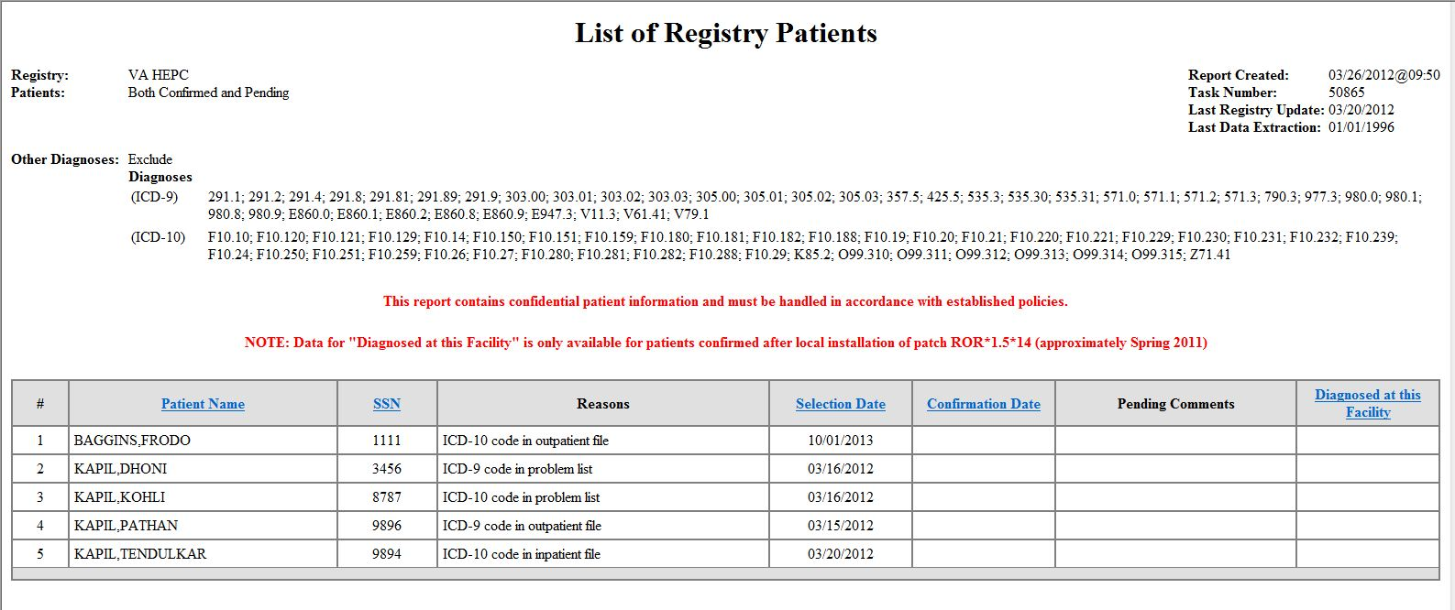

Dual Code Display
The CCR package has the ability to display either ICD-9-CM and ICD-10-CM diagnoses in the Reason for Selection column within the VistA Clinical Case Registry Patient Data Editor Selection Rules. This is determined based on the following:
- The date the patient is added to the registry
- The registry extract identifying a patient with the code set active for that date.
Based on those criteria, the CCR package then provides the ability to report either “ICD-10 code” or "ICD-9 code" descriptions, as appropriate, for the Reason for Selection of the patient to the registry.
List of Registry Patients Reasons for Selection ICD-10 Reasons
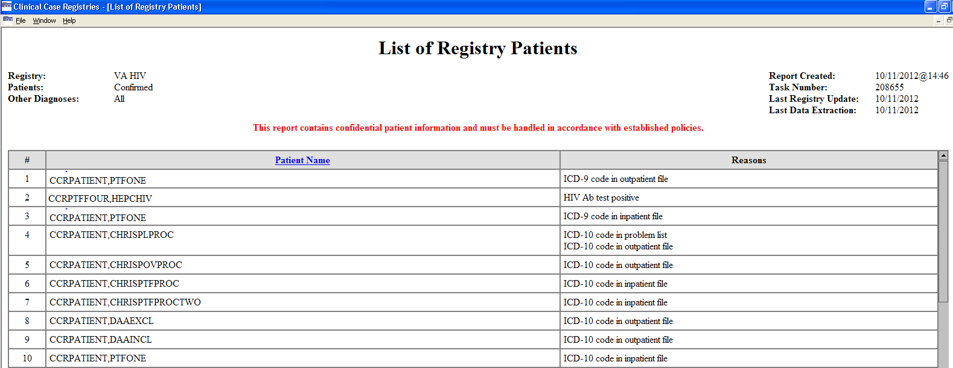

Diagnoses and Procedures Reports

Diagnosis Reports
The CCR Diagnoses and Procedures Reports now use the generic ICD diagnosis code and procedure code designation “ICD” in the report header, the section headers, and the column headers.
CCR Diagnosis and Procedures Report Headers
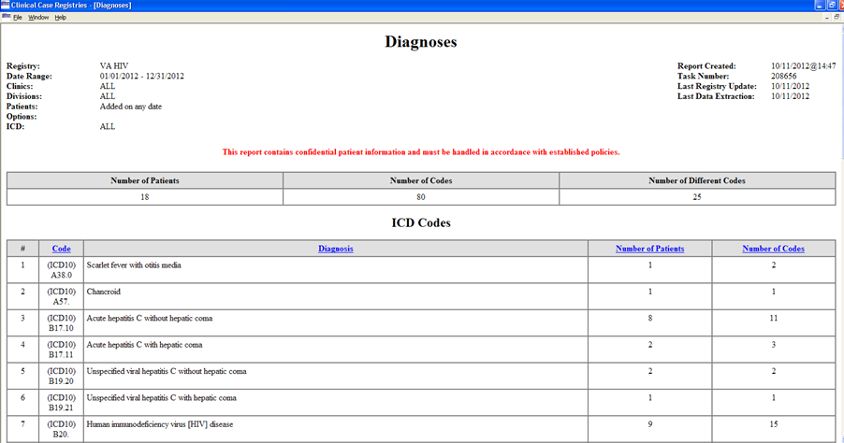

For the Diagnoses Report, the CCR package now prints the column and sections headers with the generic code set indicator “ICD”.

Diagnosis Report Column and Section Headers
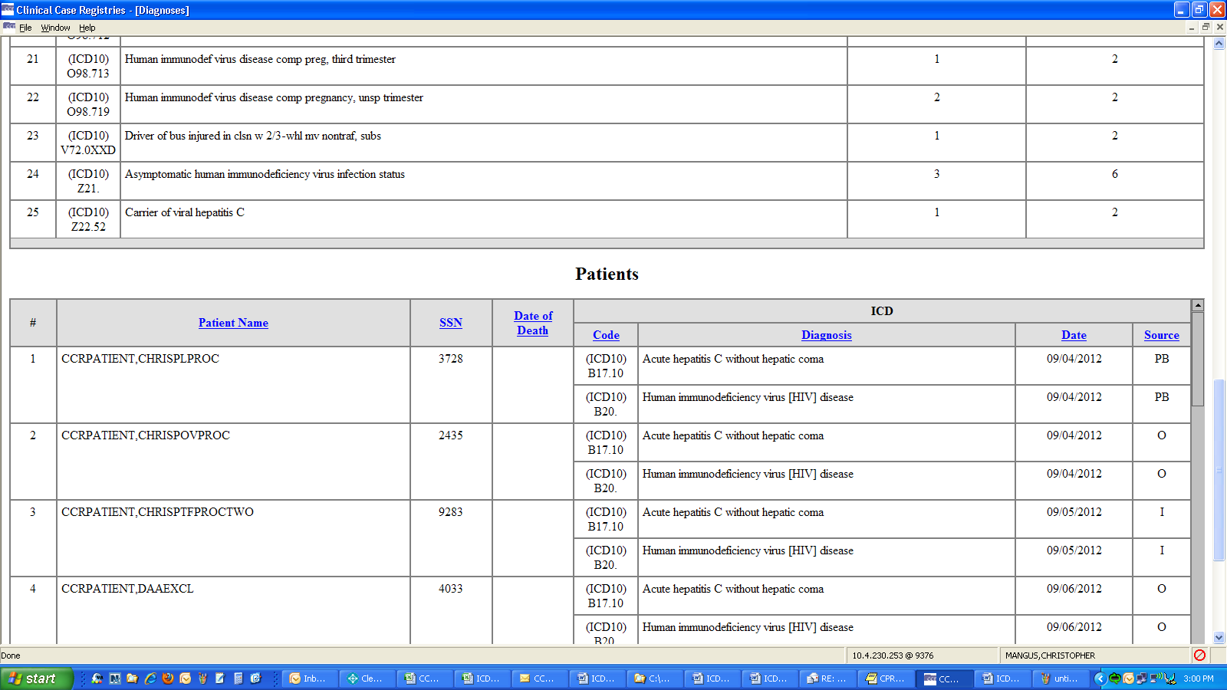

Procedure Reports
For the Procedures Report, the CCR package now displays “Inpatient (ICD)” instead of “Inpatient (ICD-9)” in the Procedures section of the Procedures Report setup screen.

Procedures Report, Procedures Section
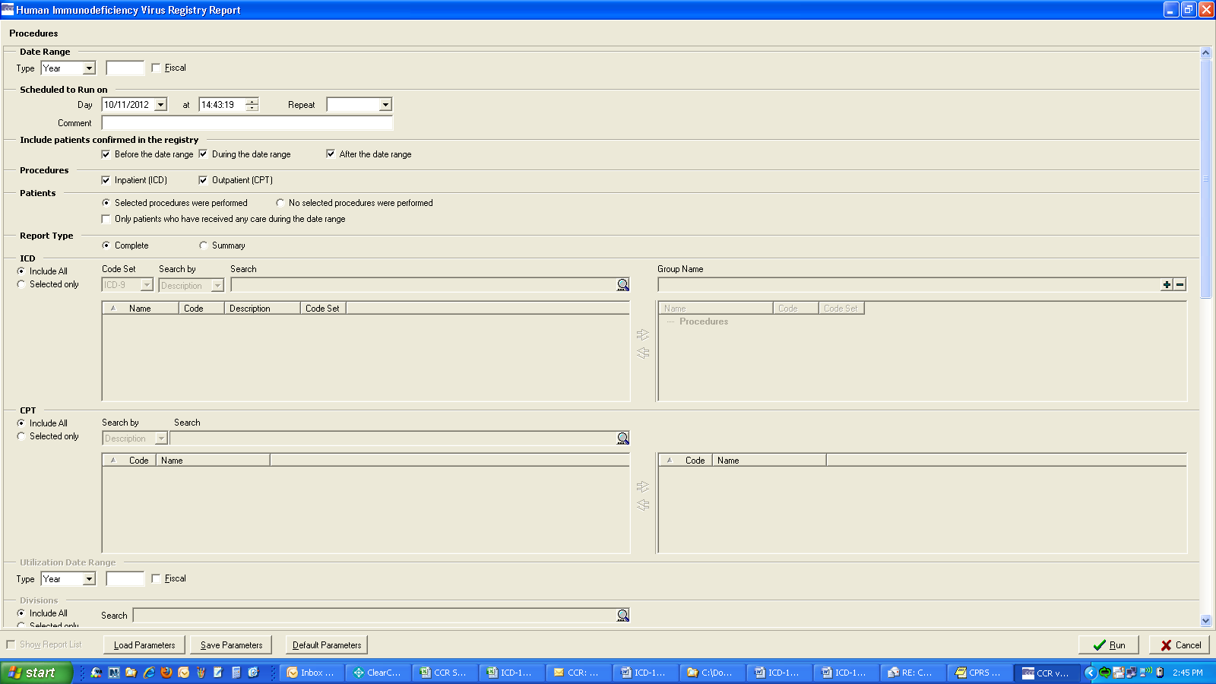

ICD Diagnosis or Procedure Code Search
The CCR package allows the user to select ICD diagnosis or procedure codes during the Diagnoses and Procedure reports setup process.
You can select either ICD-9-CM or ICD-10-CM diagnosis codes in the Diagnoses Report setup, or ICD-9-CM or ICD-10-PCS procedure codes in the Procedures Report setup within the drop-down menu.
- You can save the ICD-10 diagnoses codes in Your Templates along with ICD-9 diagnoses codes.
- The Common Templates now include ICD-10 codes.
  - Pre-install routine saves the current Common Templates in ^TMP("ROR",$J) global before updating them with ICD-9 and ICD-10 codes.
  - Any changes done to Common Templates will be lost after the installation of this patch.
Note: ICD-10 codes can be searched for prior to as well as on or after the ICD-10 Activation Date.
ICD Code Set Drop-Down Menu
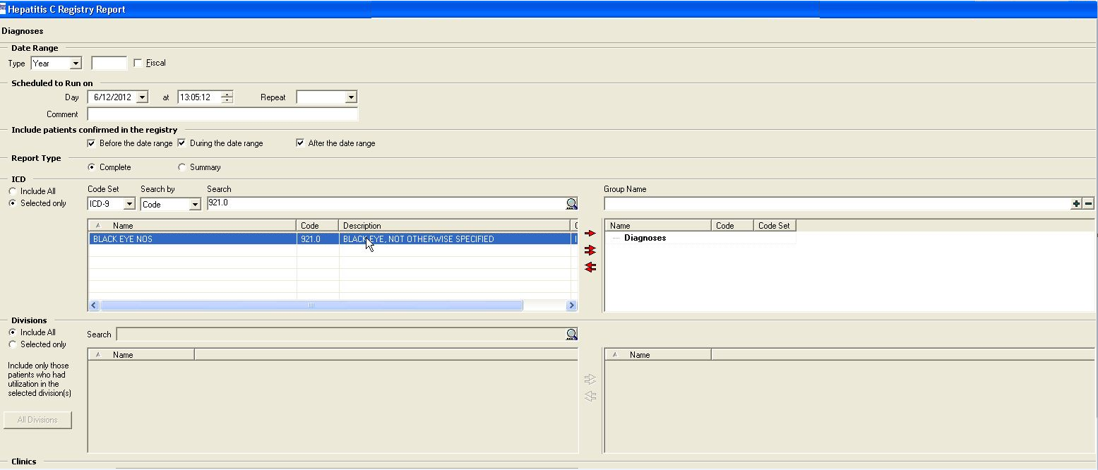

ICD Diagnosis Code Extract
The CCR package now differentiates between ICD-9-CM and ICD-10-CM diagnosis codes in the Data Extraction Process.
The nightly extract continues to extract ICD-9 codes (because of backpulls for new patients where all historical data for the past 20 years is extracted and overlap time) and are able to extract ICD-10 codes from whatever fields have new ICD-10 codes.
The Dates of Interest are specific to the dates of registry-specific diagnosis or lab test results found in the searched files, and are the dates upon which the code set for the extract is based.

Historical Encounters
The CCR package is able to extract patients from historical encounters that contain HEPC or HIV ICD diagnosis codes by changing the Date of Interest from the historical encounter visit date to the date the historical encounter was created.
To allow a patient to be added to the pending list of the registry if the following conditions for the historical encounter visit date are met:
- The visit date is on or after the ICD-10 Activation date.
- The visit date is created on or after the ICD-10 Activation date.
- The visit date contains HEPC or HIV ICD10 diagnosis codes.
In CPRS, Date/Time of Visit is prior to current date:
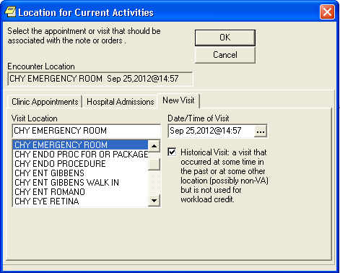

ICD Diagnosis and Procedure Code Transmission
The CCR package is able to differentiate between ICD-9-CM and ICD-10-CM diagnosis codes in the transmission process from VistA sites to the National Database and also support the new ICD-10-CM Diagnosis Code set in the HL7 messaging process.
The Dates of Interest are specific to the dates of registry-specific diagnosis or lab test results found in the searched files. If the date of interest is on or after the ICD-10 Activation Date the CCR package has the ability to do the following:
- Transmit ICD-10-CM diagnosis codes up to eight characters (including the decimal point that follows the third character).
- Transmit an ICD-10-CM diagnosis code set indicator/flag.
- Transmit “Automatically Added – ICD10” or “Automatically Added – ICD10 and Lab” table code descriptions, but this is only true if the Reason for adding the patient to the registry is because the extract code found a registry-specific ICD-10 diagnosis code.
The same is true for the new ICD-10-PCS procedure code set in the HL7 messaging process. If the date of interest is on or after the ICD-10 Activation Date, the CCR package has the ability to do the following:
- Transmit ICD-10-PCS procedure codes up to eight characters (including the decimal point that follows the third character).
- Transmit an ICD-10-PCS procedure code set indicator/flag.

Technical Information

Routines
Some CCR routines were modified to replace direct global reads and old APIs with new Standards and Terminology Services (STS) APIs and Lexicon APIs wherever possible. The following new routines are added:
Routine / File Name | Function
RORP019 | Post-Install routine to update records in ROR REGISTRY PARAMETERS (File #798.1) and update and add new records in ROR SELECTION RULE (File #798.2)
ROR Selection Rule (File #798.2) | CODING SYSTEM (#7)
 | VA HIV PROBLEM (ICD10)
 | VA HIV PTF (ICD10)
 | VA HIV VPOV (ICD10)
 | VA HEPC PROBLEM (ICD10)
 | VA HEPC PTF (ICD10)
 | VA HEPC VPOV (ICD10)
ROR XML ITEM (File #799.1) | ICD
 | ICD10
 | ICDFILT
 | ICDLST

GUI Installation Instructions

Pre-Installation Instructions
Patch ROR*1.5*19 identification is as follows:
- File Name: ROR1_5P19GUI.ZIP
- GUI Version: ROR1_5P19
- Contents: Zipped GUI
- Transfer Mode: Binary
- CRC Number: DCDD0E34
Patch ROR*1.5*19 includes a revised Graphical User Interface (GUI) application distributed to the appropriate workstations. After the patch is installed correctly, and the GUI is updated, the version of the GUI will be 1.5.19.
- Unzip the ROR1_5P19GUI.ZIP into a temporary folder.
- Open the temporary folder and double-click the file CCRSetup.exe to begin the install.
- Wait until the setup Wizard prepares the installation procedure. A Welcome message displays.
- Click Next to continue the installation.
- Select the directory in which to install the CCR GUI. We recommend that you accept the default directory C:\Program Files\VistA\Clinical Case Registries.
Note: To select a different location, click Change and select the directory.
- Click Next to proceed with installation.
- Review the installation settings and click Install to proceed. The setup Wizard finishes the installation and a confirmation screen displays.
- Click Finish.
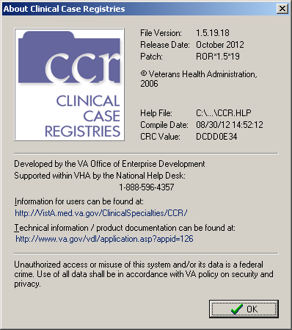

UnInstall Instructions
To uninstall the GUI, use the“Uninstall Clinical Case Registries” option of the “Clinical Case Registries” section of the “Programs” menu.
(This page intentionally left blank)

